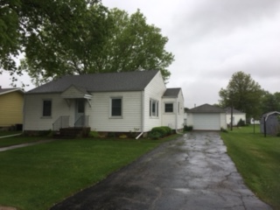

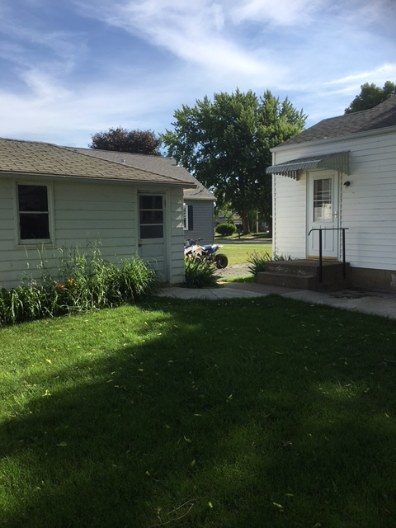

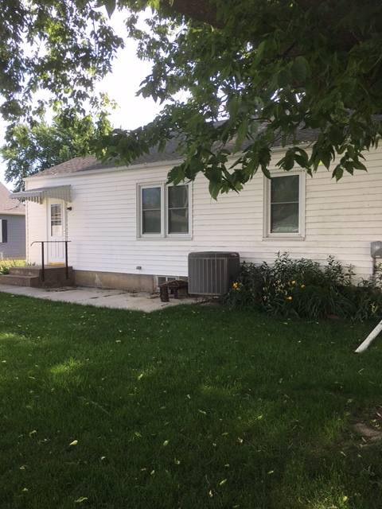

113 N ORIN STREET
PRESTON, IA
- 2 or 3 Bedroom – 1 Level Home – 1094 Sq Ft
- Built in 1956
- Lot Size 60’ X 120’
- Unattached 1 Car Garage
- Foundation – Poured Concrete – Full Basement
- Roof Replaced
- Windows Replaced
- Kitchen – Dining – Open – Nice Cabinets and Floor
- Living Room has Plaster Walls, Ceiling Fan, and Hardwood Floors
- 2 Bedrooms Have Plaster Walls – Carpet and Closets
- 1 Room Could be a Small Bedroom – Hardwood Floor No Closet (Could Also Be Laundry Storage Room)
- 1 Full Bath Up and ½ Bath in the Basement
- Furnace – Water Heater – Softener All New
** See Attached Sheet of Updates
TAXES: $1220.OO/YR
PRICE: $93,000.00
IMPROVEMENTS MADE TO 113 N ORIN STREET RENTAL HOUSE

Original Cost…………………………………………………………………………………………………………………….. $ 70,000.00
2010 – Top of the line furnace, Heat Pump AC, Air purifier and duct work and labor………. $ 8500.00
New roof and labor to Donnie and Dale Roling ……………………………………………………. 2100.00
New archway between kitchen and living room, materials only…………………………… 350.00
2011 – Replaced all windows with double pane, High efficiency and labor to install ………. 4480.00
New service to house, breaker box, (from 60 AMP to 200 AMP), Wiring to garage etc. 3500.00
New insulated garage door, opener and labor to frame it ……………………………………. 996.00
Replaced all water lines in basement …………………………………………………………………… 843.00
New front door, glass storm door, back door and storm door ……………………………… 450.00
Closed 2 basement windows in front, materials only …………………………………………… 100.00
Bathroom attic fan, materials only ……………………………………………………………………….. 50.00
2013 – Concrete small patio and side walk to garage ………………………………………………………. 250.00
2014 – Repair sewer line outside (caved in) ………………………………………………………………….…. 685.00
2015 – New drain pipe for washing machine, kitchen sink, and labor to tear up floor, cement 1035.00
Turbo attic vent, materials and labor …………………………………………………………………… 100.00
New drain pipe to tub and sink, installed shower surround, material only …………. 135.00
2016 – Water softener …………………………………………………………………………………………………….. 400.00
2017 – New carpet in bedrooms and linoleum in kitchen, dining room …………………………… 1700.00
Total Improvements ………………………………………………………………………………………………………... 25,674.00
Original cost of house ………………………………………………………………………………………………………. 70,000.00
Total invested in house ………………………………………………………………………………………………… $95,674.00

