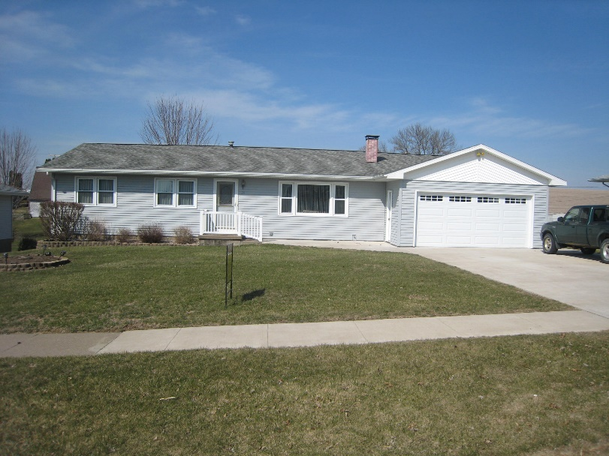

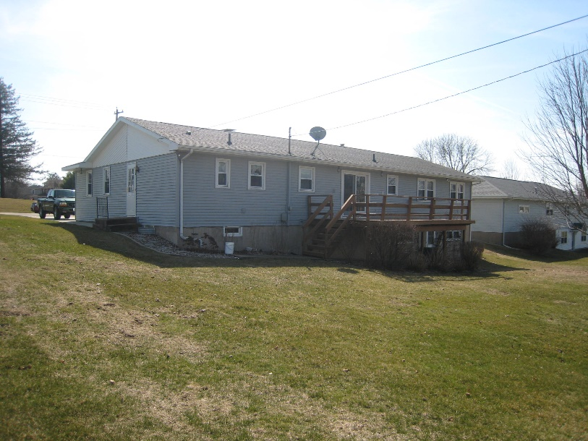

#38 SECTION RD
MILES, IOWA

- 4 BEDROOM RANCH STYLE HOME - 1568 SQ FT
- BUILT 1967
- LOT SIZE 90’ X 200’
- ATTACHED 2 CAR GARAGE – NEW DOOR AND OPENER
- FOUNDATION POURED CONCRETE
- FULL WALK-OUT BASEMENT
- ROOF REPLACED 2011-2012 NEW SHEETING WHERE NEEDED
- WINDOWS REPLACED UP AND DOWN 2004-2005
- KITCHEN/DINING OPEN – NEW FRENCH DOORS AND FLOOR IN 2000 (STOVE, REFRIGERATOR, WASHER AND DRYER STAY) UTILITY ROOM MAIN LEVEL
- LIVING ROOM HAS PLASTER WALLS, CARPET, CEILING FAN, FIREPLACE AND MANTEL
- BEDROOMS HAVE CARPET, PLASTER WALLS – ALL HAVE CLOSETS
- BATHROOMS 2 UP AND 1 DOWN
- BASEMENT IS ¾ FINISHED – GAME ROOM WITH BAR (BAR AND FRIDGE STAY). POOL TABLE, BAR STOOLS, BAR LIGHTS AND ACCESSORIES DO NOT STAY
- FURNACE IS OLDER, WATER HEATER 2005 (BOTH CITY GAS), AIR CONDITIONER 2009-2010

TAXES: $1914 NET/YR
ASKING: $132,000

FELLER REALTY · PRESTON, IA · 563-689-6480 · 563-357-7148

